**Gantt chart**

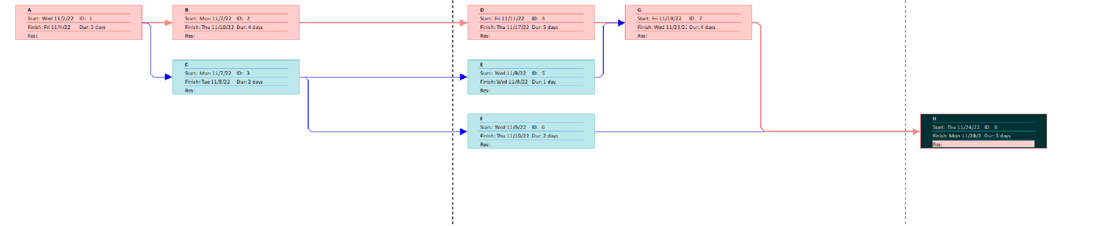

**Network diagram**

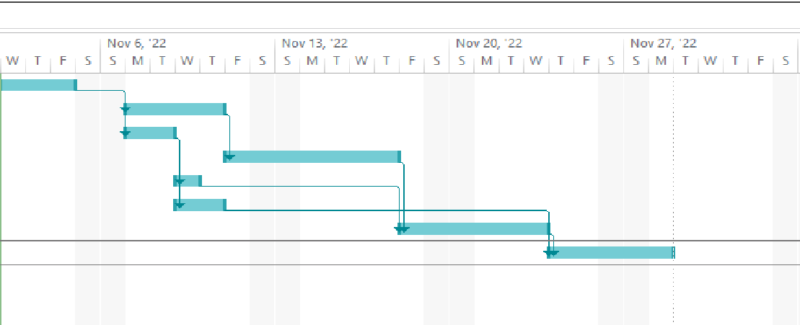

When is the delivery date?

* 15 Unit time

Which tasks could be delayed without delaying the schedule?

* Task E, F can be delayed without delaying the project